The Bundoora Family Clinic database is a centralized clinical, pharmacy, security, and inventory management system designed to connect users, doctors, patients, pharmacists, prescriptions, medicine stock, and pharmacy operations within one relational workflow.
Its architecture is organized around four core pillars:
User Management & Clinical Roles: A unified users and roles layer supports Administrator, Doctor, Patient, and Pharmacist access, with dedicated doctor, patient, and pharmacist profiles plus OTP verification, password recovery, active login-session tracking, and audit logging.
Consultations & Digital Prescribing: Appointments connect patients and doctors, while prescriptions, prescription items, prescription signatures, renewal requests, stock reservations, dispensing records, and medication tracking support the prescription lifecycle from consultation through collection and adherence.
AI-Assisted Decision Support & Safety: The knowledge base provides medicine recommendations from diagnosis keywords, while medicine-interaction and patient-allergy tables provide structured safety information that can be checked during prescribing and dispensing.
Pharmacy Logistics, Inventory & Compliance: Medicine, batch, central inventory, pharmacy inventory, pharmacy service, shortage prediction, TGA shortage, redistribution, recall, notification, and reporting structures support branch stock visibility, batch traceability, shortage monitoring, and operational control.
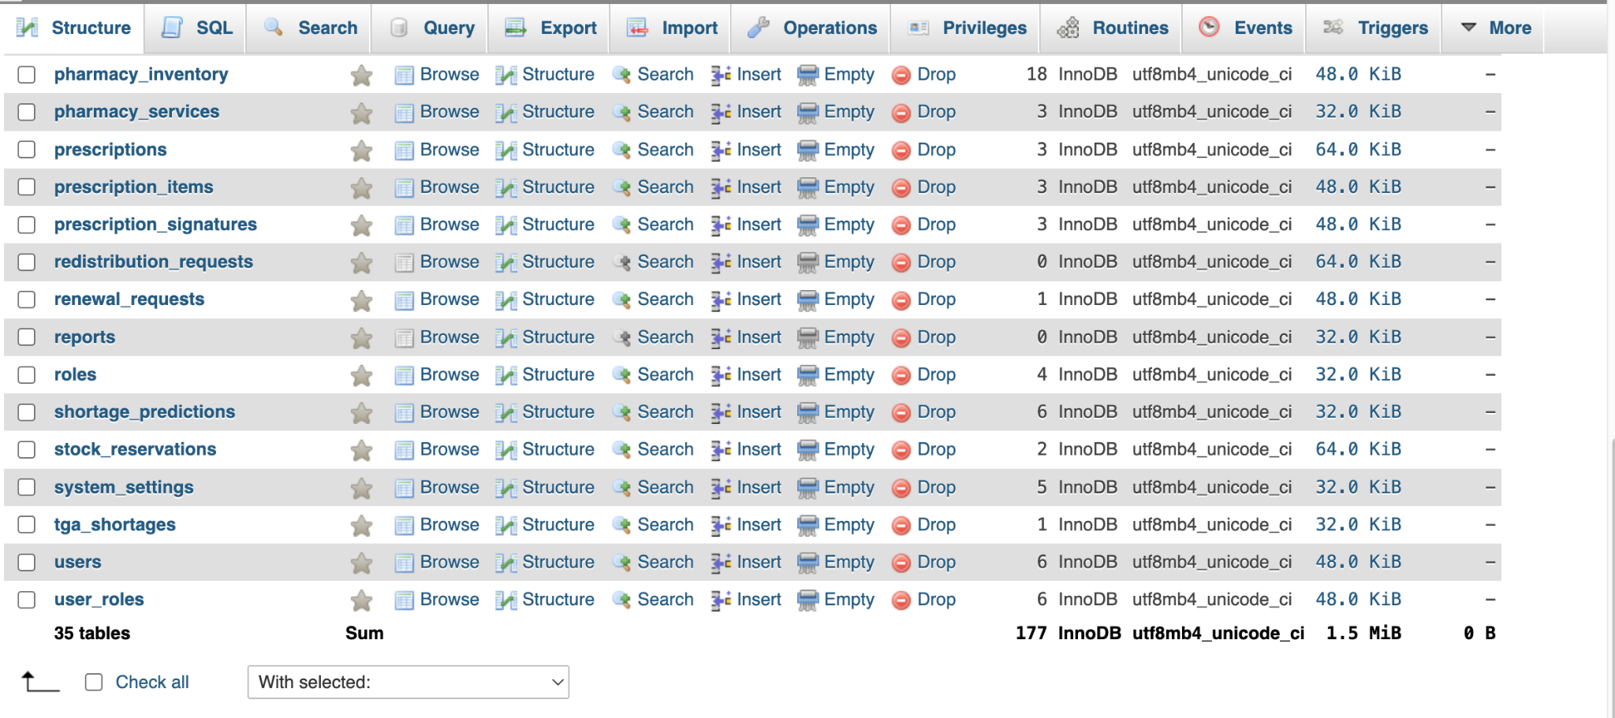

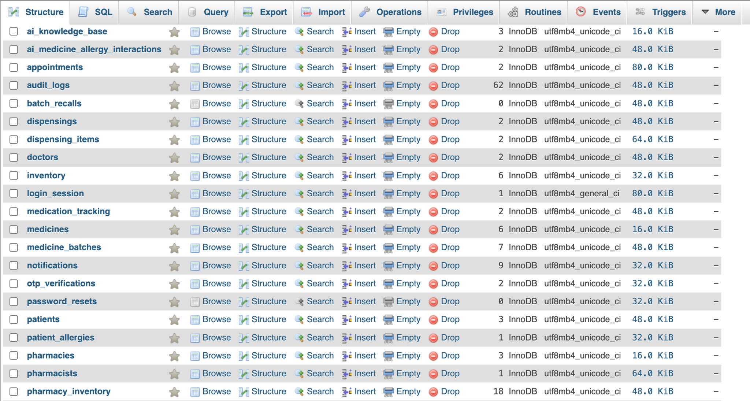
The phpMyAdmin structure view confirms a 35-table InnoDB database. The supplied structure screenshots show 177 rows in total across the current dataset and use utf8mb4 collations. The tables are separated by responsibility, with identity and access, clinical records, pharmacy stock, prescribing, dispensing, safety, notifications, forecasting, and system configuration maintained in dedicated relational structures.

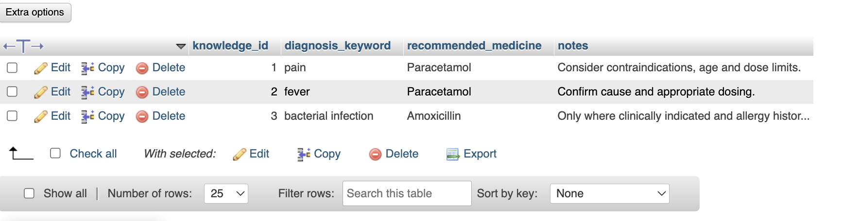
Functions as a clinical recommendation knowledge table. It stores a knowledge_id for each rule, a diagnosis_keyword such as pain, fever, or bacterial infection, the recommended_medicine text, and supporting notes. The visible examples recommend Paracetamol for pain and fever and Amoxicillin for bacterial infection, while the notes remind the application or clinician to consider contraindications, age, dose limits, cause, allergy history, and whether treatment is clinically indicated.

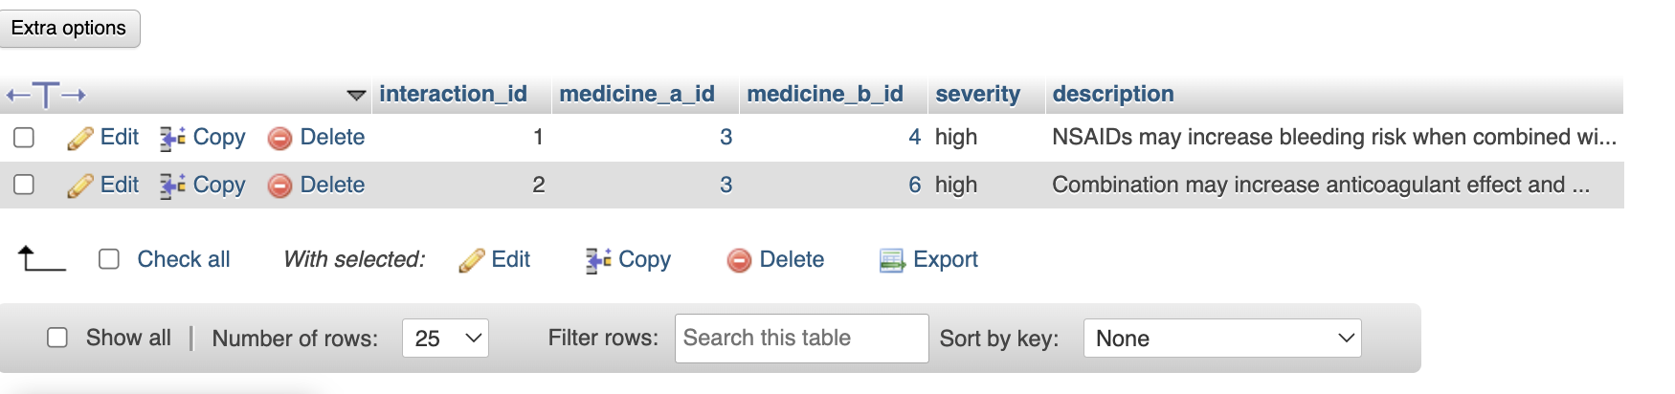
Acts as a medicine interaction safety registry. Each interaction record links two medicines through medicine_a_id and medicine_b_id, assigns a severity level, and stores a human-readable description of the risk. The visible records are marked high severity and describe increased bleeding or anticoagulant effects. This structure gives the application a direct source for warning users when two medicines in the same treatment plan may require additional clinical review.

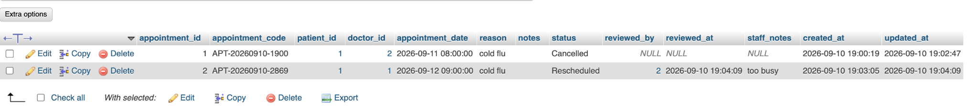
Manages appointments between patients and doctors. Each row has an appointment_id and appointment_code and links a patient_id with a doctor_id at an appointment_date. The record also stores the reason, notes, current status, review details through reviewed_by and reviewed_at, optional staff_notes, and created/updated timestamps. The sample data demonstrates appointment lifecycle handling, including a cancelled booking and another booking that was rescheduled after staff review.

Provides a system activity audit trail. The audit_logs table records the acting user_id, the action performed, the entity_type and entity_id affected, the originating ip_address, the outcome status, and the created_at timestamp. The visible examples include a successful login and a successful user update. These records support accountability by showing who performed an operation, what type of record was involved, where the request originated, and whether the operation succeeded.

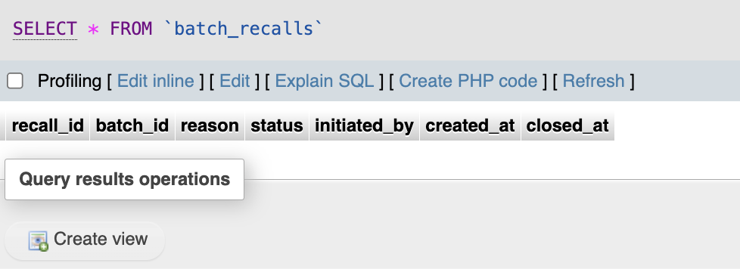
Supports medicine batch recall management. Its fields include recall_id, batch_id, reason, status, initiated_by, created_at, and closed_at, allowing a recall to be opened against a specific medicine batch, assigned a reason, tracked through a status, and closed when resolved. The supplied screenshot currently shows no recall records, but the table structure is present for documenting and controlling recalled or otherwise unsafe stock at batch level.

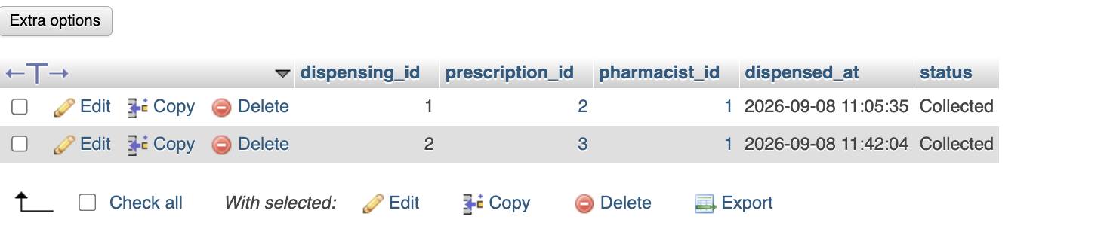
Records completed or in-progress prescription dispensing events. Each dispensing has a dispensing_id linked to a prescription_id and pharmacist_id, together with the dispensed_at timestamp and a status. The sample records show two prescriptions dispensed by pharmacist 1 and marked Collected. This header-level table therefore provides the main fulfillment record that connects an approved prescription to the pharmacist who supplied it and the final collection state.

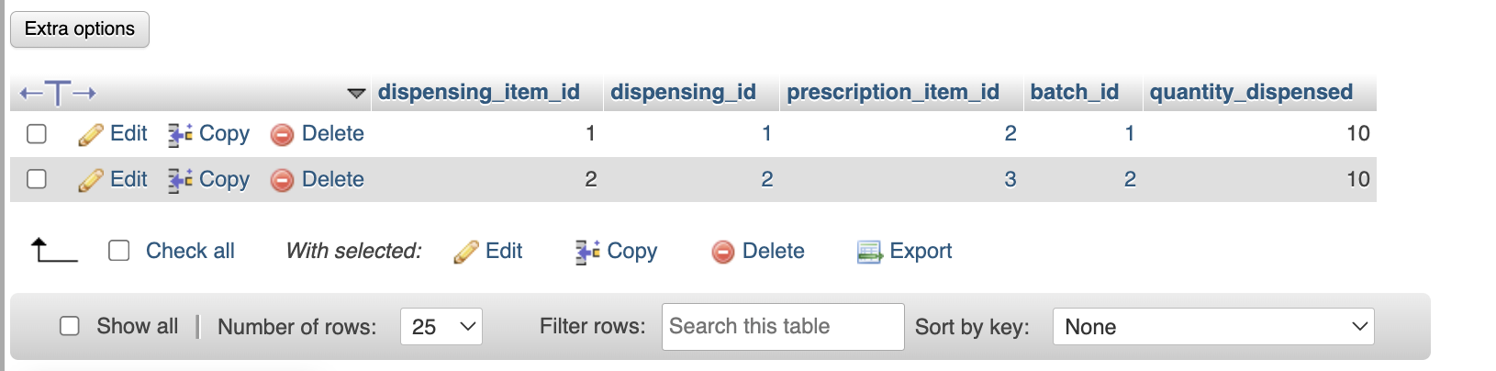
Stores the line-level stock details for each dispensing. A dispensing_item_id links to the parent dispensing_id and to a prescription_item_id, while batch_id identifies the exact medicine batch used and quantity_dispensed records how many units were supplied. The visible rows show quantities of 10 taken from batches 1 and 2. Capturing both the prescribed item and the batch provides traceability from the prescription through to the physical stock used for fulfillment.

